Event Capture System (ECS)

Graphical User Interface

Technical Manual

Software Version 2.0

Patch EC*2.0*134



July 2017

Document Version 1.0

Department of Veterans Affairs (VA)

Office of Information Technology (OI&T)

Document Revision History

| Date | Version | Description | Author |
| --- | --- | --- | --- |
| 7/31/2017 | 1.0 | Initial Document Release | TeamSMS/Leidos |

Table of Contents

1 Introduction 1

1.1 Purpose 1

1.2 Product Perspective 1

1.3 Security Keys 2

1.4 Functions of the Software 2

1.5 Related Documentation 2

2 Implementation and Maintenance 3

2.1 Namespace 3

2.2 Site Configuration 3

2.3 Resource Requirements 3

3 Routines 4

3.1 Callable Routines 4

3.2 Routines to Map 4

3.3 Routine List 4

4 Files 5

4.1 Global Placement 5

4.2 File List 5

4.3 Templates and File Flow 5

5 Exported Options 7

5.1 Menu Outline 7

5.2 Menu Diagram 7

6 Archiving and Purging 10

7 Package-Wide Variables 11

8 External / Internal Relations 12

8.1 External Relations 12

8.2 Database Integration Agreements 12

8.3 Internal Relations 12

8.4 External Interfaces 13

9 Security 14

9.1 Security Management 14

9.2 Security Keys 14

9.3 VA FileMan Access Codes 14

9.4 Mail Groups and Alerts 15

9.5 Remote Systems 15

9.6 Contingency Planning 15

9.7 Interfacing 15

9.8 Electronic Signatures 15

10 How to Generate On-Line Documentation 16

10.1 XINDEX 16

10.2 List File Attributes 16

10.3 On-Line Help 16

Appendix A Acronyms A-1

Appendix B Glossary B-1

List of Tables

Table 1: File Export 5

Table 2: Mapping File Flow 5

Table 3: Required VistA Software Products 12

Table 4: FORUM Steps 12

Table 5: VA FileMan Access Codes 14

Table 6: Acronyms A-1

Table 7: Glossary B-1

List of Figures

Figure 1: Main Menu for Event Capture 7

Figure 2: Data Entry Menu Screen 7

Figure 3: Spreadsheet Menu Screen 8

Figure 4: Reports Menu Screen without ECMGR Options 8

Figure 5: Reports Menu Screen with ECMGR Options 9

Figure 6: Management Menu Screen 9

# Introduction

The Event Capture System (ECS) is a Veterans Health Information Systems and Technology Architecture (VistA) Class I workload reporting system supporting operations of the Department of Veterans Affairs (VA) Managerial Cost Accounting Office (MCAO). There are several Veterans Health Administration (VHA) national programs mandating using ECS instead of, or to augment, other workload capture information systems. For example, ECS is used when programs cannot report workload in the form of Current Procedural Terminology (CPT) codes. ECS also allows for more precise workload capture and reporting than otherwise possible through other VistA systems.

## Purpose

The Event Capture Technical Manual serves a dual purpose:

* Provides technical information to aid Information Resources Management (IRM) service staff with implementing and maintaining the software
* Provides security information for Information Security Officers (ISO)

## Product Perspective

ECS captures basic resource utilization data which is reported in VistA and also fed to the Decision Support System (DSS) in the DSS ECS monthly extract. The Event Capture software provides a mechanism to track and account for procedures and delivered services that other VistA packages do not handle. The procedures and services tracked through Event Capture are associated with the following:

* The patient to whom they were delivered
* The provider requesting the service or procedure
* The DSS Unit responsible for delivering the service

Information entered into ECS will then be sent electronically to DSS, Patient Care Encounter (PCE), and billing offices for processing which will in turn facilitate workload analysis, cost analysis and transmission of billing.

DSS Units typically represent the smallest identifiable work unit in a clinical service at a medical center. Veterans Affairs Medical Centers (VAMC) define the DSS Units. A DSS Unit can represent any of the following:

* An entire service
* A section of a service
* A small section within a section
* A medical equipment item used in patient procedures

The user must define the following items for every DSS Unit:

* Service: The service associated with the DSS Unit
* Cost Center: The fiscal identifier for the service using the particular DSS Unit
* Medical Specialty: The specialty section associated with the DSS Unit

## Security Keys

Security keys are assigned in VistA using the menu option **Key Management**, and then choosing the submenu **Allocation of Security Keys**.

* ECMGR: Gives a user access to the ECS Management Menu. This key is intended to be used only for Event Capture Managers.
* ECALLU: Gives a user access to all DSS Units (super user). This should be assigned only to those managing the software (i.e., holders of the ECMGR key).
* ECNORPT: Restricts the user from access to the Event Capture Reports.
* ECSPSH: Gives a user access to upload data from a spreadsheet.

## Functions of the Software

Event Capture with all patches installed provides the following functions:

* Allows each VAMC to utilize the software for its own resource/costing needs
* Implements DSS Units
* Assigns user access to the DSS Units
* Allows single and batch data entry for patient procedures
* Generates reports for workload and other statistical tracking
* Provides a Graphical User Interface (GUI) to the ECS application
* Allows the user to upload patient encounter data to Event Capture from a spreadsheet
* Allows the user to switch between Computerized Patient Record System (CPRS) and ECS without having to log back into the ECS GUI application

## Related Documentation

In addition to this technical manual, Event Capture documentation includes the following:

* Event Capture User's Guide
* Event Capture Deployment, Installation, Back-Out, and Rollback Guide
* Event Capture Version Description Document

Documentation and additional information for this product—including background, technical and procurement information—can be found on the [VA Software Documentation Library (VDL)](http://www.va.gov/vdl/application.asp?appid=39) intranet site.

# Implementation and Maintenance

This section contains general information related to implementation and maintenance of the ECS application in the target VA software environment.

## Namespace

The namespace for Event Capture is EC. The excluded namespaces are ECT, ECW, ECX, and EC1.

## Site Configuration

Event Capture does not require site parameters.

## Resource Requirements

There are approximately 250 Event Capture routines that take up approximately 997KB of disk space (including pre-initialization and post-initialization routines).

# Routines

This section contains relevant information for ECS GUI application software routines, and describes the actions to perform in order to obtain a list of routines supporting ECS that are implemented in the back-end Massachusetts General Hospital Utility Multi-Programming System (MUMPS) environment. Event Capture is comprised of a number of MUMPS routines that enable entering, editing, and deleting of data, as well as producing reports. These routines are used to accomplish user-initiated tasks through the ECS GUI component.

## Callable Routines

The Event Capture software uses Integration Agreement 4460 to call the Application Programmer Interface (APIs) to store and retrieve data for the PROVIDER MULTIPLE field (#42) in the EVENT CAPTURE PATIENT file (#721).

## Routines to Map

There are no specific requirements for routine mapping.

## Routine List

Perform the following steps from the VistA Systems Manager Menu to obtain the MUMPS routines contained in the Event Capture software:

1. Programmer Options
2. Routine Tools
3. First Line Routine Print
4. All Routines? No => <**Enter**>
5. Routine: **EC\***
6. Routine: ‘ECT*
7. Routine: ‘ECW*
8. Routine: ‘ECX*
9. Routine: ‘EC1*
10. Routine: <**Enter**>
11. (A)lpha, (D)ate, (P)atched, OR (S)ize ORDER: A//<**Enter**>
12. Include line (2), Include lines 2&(3), (N)one: None//<**Enter**>
13. DEVICE: HOME// <**Enter**> SSH VIRTUAL TERMINAL Right Margin: 80// <**Enter**>

Steps 6-9 are to exclude those routines from appearing in the list.

# Files

This section contains information related to files used by the ECS application. It identifies files exported, and describes the steps necessary to obtain a list of templates and map the file flow relationships for Event Capture. Event Capture uses a series of FileMan files to store data related to workload entered via the ECS GUI.

## Global Placement

Event Capture with all patches installed creates the following global files: ^EC, ^ECC, ^ECD, ^ECH, ^ECJ, ^ECL, and ^ECR. Global protection and placement should be made on all of them. It is possible that one or more of these global files already exist on your system.

## File List

Table 1 lists the Event Capture files with all exported patches installed. [VA Directive 6402 Modifications to Standardized National Software, 8/28/2013](http://vaww.va.gov/vapubs/viewPublication.asp?Pub_ID=718&FType=2) governs these files. Use the List File Attributes option in VA FileMan to print the Data Dictionary (DD).

1. File Export

| File Number | File Name |
| --- | --- |
| 720.1 | EVENT CAPTURE LOG |
| 720.3 | EC EVENT CODE SCREENS |
| 720.4 | EC PROCEDURE REASON |
| 720.5 | EC EVENT CODE SCREENS/PROC REASON LINK |
| 721 | EVENT CAPTURE PATIENT |
| 722 | EVENT CAPTURE PROVIDER |
| 723 | MEDICAL SPECIALTY |
| 724 | DSS UNIT |
| 725 | EC NATIONAL PROCEDURE |
| 726 | EVENT CAPTURE CATEGORY |

## Templates and File Flow

Table 2 lists the steps from the VistA Systems Manager Menu to obtain the templates and map the file flow relationships for Event Capture with all patches installed.

1. Mapping File Flow

| Step | Templates | File Flow  (Relationships between Files) |
| --- | --- | --- |
| 1 | VA FileMan | VA FileMan |
| 2 | Print File Entries | Data Dictionary Utilities |
| 3 | OUTPUT FROM WHAT FILE: **Print Template** or **Sort Template** | Map Pointer Relations |
| 4 | SORT BY: Name// **Name** | Select PACKAGE NAME: **Event Capture** |
| 5 | START WITH NAME: FIRST//EC <**Enter**> | Remove FILE: <**Enter**> |
| 6 | GO TO NAME: ECW// <**Enter**> | Add FILE: (**Enter name or file number for files you want to include in the output. This prompt will repeat until next step.**) |
| 7 | WITHIN NAME, SORT BY: <**Enter**> | Add FILE: <**Enter**> |
| 8 | FIRST PRINT FIELD: **Name** | Enter Name of file group for optional graph header: EVENT CAPTURE// <**Enter**> |
| 9 | THEN PRINT FIELD: <**Enter**> | DEVICE: HOME// <**Enter**> HOME (CRT) |
| 10 | Heading (S/C): PRINT TEMPLATE LIST// <**Enter**> |  |
| 11 | START AT PAGE: 1 <**Enter**> |  |
| 12 | DEVICE: <**Enter**> HOME (CRT) Right Margin: 80// <**Enter**> |  |

# Exported Options

This section provides an overview of the main and submenus available in the ECS GUI application. The user must hold the appropriate security keys in order to access all options.

## Menu Outline

The Event Capture software contains the Data Entry, Spreadsheet, Reports, and Management Menu options that are fixed and not subject to modification, except by the software developer(s). Figure 1 shows these major menu options as they appear in the GUI.

1. Main Menu for Event Capture

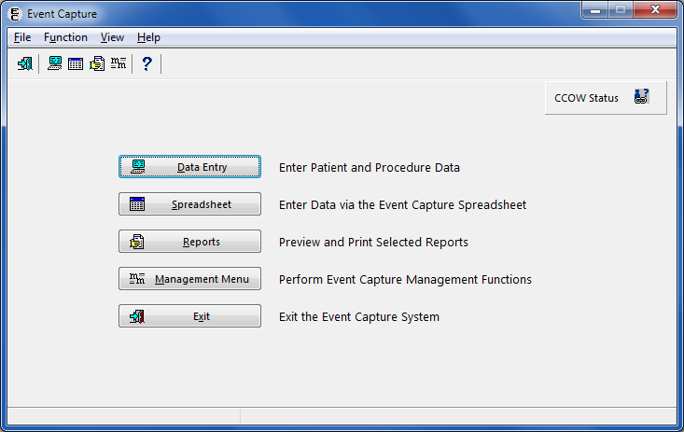

## Menu Diagram

Figure 2 shows the submenu items that are available when the Data Entry option is selected from the Main Menu.

1. Data Entry Menu Screen

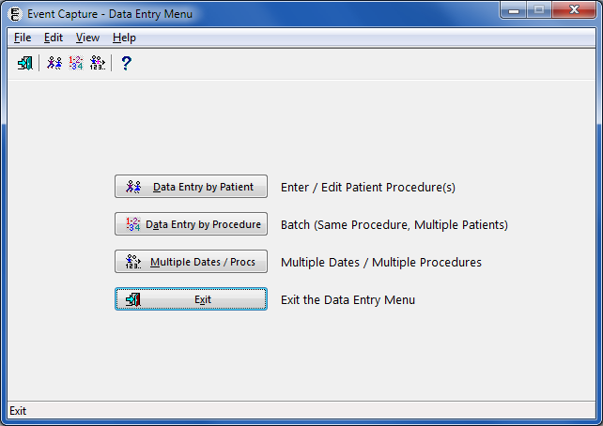

Figure 3 shows the submenu items that are available when the Spreadsheet option is selected from the Main Menu. The user must hold the ECSPSH security key in order to access this screen.

1. Spreadsheet Menu Screen

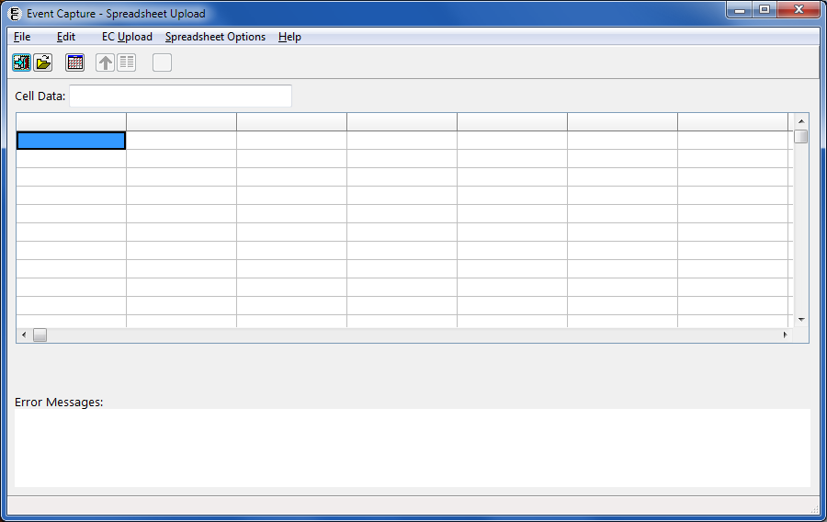

Figure 4 shows the submenu items that are available when the Reports option is selected from the Main Menu and the user does not hold the ECMGR security key.

1. Reports Menu Screen without ECMGR Options

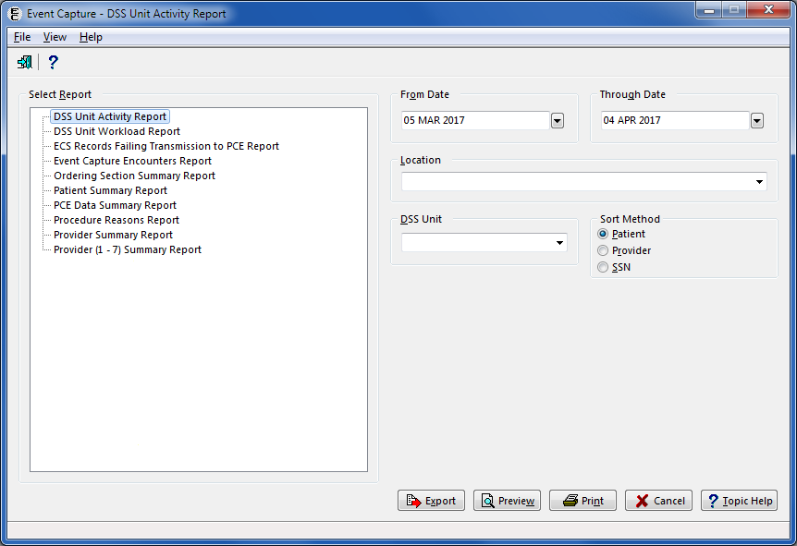

Figure 5 shows the submenu items that are available when the Reports option is selected from the Main Menu and the user holds the ECMGR security key.

1. Reports Menu Screen with ECMGR Options

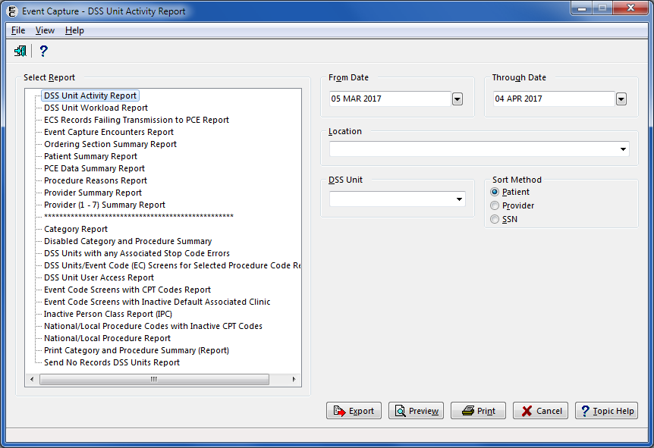

Figure 6 shows the submenu items that are available when the Management Menu option is selected from the Main Menu. The user must hold the ECMGR security key in order to access this menu.

1. Management Menu Screen

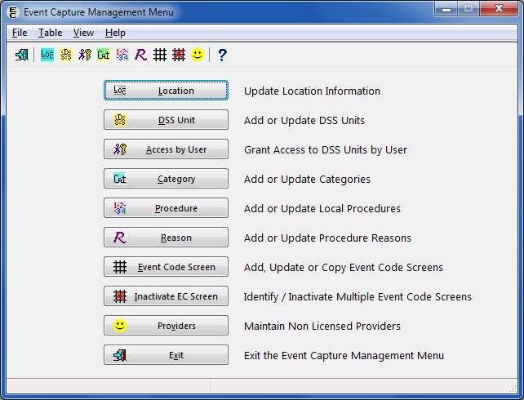

# Archiving and Purging

The Event Capture software does not provide for the archiving or purging of its data.

# Package-Wide Variables

There are no package-wide variables in this version of the Event Capture software.

# External / Internal Relations

This section identifies internal and external VistA dependencies of the ECS application. It also identifies the steps necessary to obtain a list of Database Integration Agreements (DBIA) in place for interfacing with required VistA products. Event Capture is part of a larger integrated medical records system and relies on data from other packages to perform its functions.

## External Relations

Table 3 lists the VistA software products that must be installed before installing Event Capture.

1. Required VistA Software Products

| Product Name | Minimum Version |
| --- | --- |
| CPT/Healthcare Common Procedure Coding System (HCPCS) Codes | 6.0 |
| Diagnosis Related Group (DRG) Grouper | 18 |
| Kernel | 8.0 |
| MailMan | 8.0 |
| Patient Care Encounter (PCE) | 1.0 |
| Patient Information Management Service (PIMS) | 5.3 |
| Registration | 5.2 |
| Remote Procedure Call (RPC) Broker | XWB*1.1*65 |
| ToolKit | 7.3 |
| VA FileMan | 22.2 |

## Database Integration Agreements

Table 4 lists the steps in FORUM from the Software Services Primary Menu.

1. FORUM Steps

| Step | Custodial Package | Subscriber Package |
| --- | --- | --- |
| 1 | DBA MENU | DBA MENU |
| 2 | INTEGRATION CONTROL REGISTRATIONS | INTEGRATION CONTROL REGISTRATIONS |
| 3 | Custodial Package Menu | Subscriber Package Menu |
| 4 | ACTIVE ICRs by Custodial Package | Print ACTIVE by Subscribing Package |
| 5 | Select PACKAGE NAME: **EC** | START WITH SUBSCRIBING PACKAGE: RA// **EVENT CAPTURE** |
| 6 | DEVICE HOME// <**Enter**> | GO TO SUBSCRIBING PACKAGE: LAST// **EVENT CAPTURE** |
| 7 | This step blank on purpose | DEVICE: <**Enter**> |

## Internal Relations

All of the Event Capture options are designed to stand alone. Each option can be independently invoked.

## External Interfaces

The Event Capture software does not interface with systems outside of VistA. For ECS interfaces to other applications within VistA, please see the External Relations section.

# Security

This section identifies security measures that must be in place for normal operation of the ECS application. Event Capture security is maintained through the use of security keys, file protection, and option assignment in addition to standard VistA logon security.

## Security Management

The Event Capture software does not impose any additional legal requirements on the user, nor does it relieve the user of any legal requirements.

## Security Keys

Take the following steps from the VistA Systems Manager Menu to obtain information about the security keys contained in the Event Capture software:

1. VA FileMan
2. Print File Entries
3. OUTPUT FROM WHAT FILE: PRINT TEMPLATE// **Security Key**
4. SORT BY: NAME// <**Enter**>
5. START WITH NAME: FIRST// **EC**
6. GO TO NAME: LAST// **ECX**
7. WITHIN NAME, SORT BY: <**Enter**>
8. FIRST PRINT FIELD: **Name**
9. THEN PRINT FIELD: **Description**
10. THEN PRINT FIELD: <**Enter**>
11. Heading (S/C): SECURITY KEY LIST// <**Enter**>
12. START AT PAGE: 1// <**Enter**>
13. DEVICE: <**Enter**> HOME (CRT) Right Margin: 80// <**Enter**>

## VA FileMan Access Codes

Table 5 lists the recommended VA FileMan Access Codes for the ECS GUI Software.

1. VA FileMan Access Codes

| File  Number | File Name | Data Dictionary  (DD) Access | Read Access  (RD) Access | Write Access  (WR) Access | Delete Access  (DEL) Access | Learn-As-You-Go  (LAYGO) Access |
| --- | --- | --- | --- | --- | --- | --- |
| 720.1 | EVENT CAPTURE LOG |  |  |  |  |  |
| 720.3 | EC EVENT CODE SCREENS |  |  |  |  |  |
| 720.4 | EC PROCEDURE REASON | @ | @ | @ | @ | @ |
| 720.5 | EC EVENT CODE SCREENS/ PROC REASON LINK | @ | @ | @ | @ | @ |
| 721 | EVENT CAPTURE PATIENT |  |  |  |  |  |
| 722 | EVENT CAPTURE PROVIDER |  |  |  |  |  |
| 723 | MEDICAL SPECIALTY | @ | @ | @ | @ | @ |
| 724 | DSS UNIT |  |  |  |  |  |
| 725 | EC NATIONAL PROCEDURE |  |  |  |  |  |
| 726 | EVENT CAPTURE CATEGORY |  |  |  |  |  |

Entries in the MEDICAL SPECIALTY file (#723) are set by the MCAO or its designee. Any additions, deletions, or modifications will be distributed nationally through the release of the Event Capture software.

Entries in the EC NATIONAL PROCEDURE file (#725) are also set by the MCAO or its designee. The Event Capture Management Menu provides the option to add locally recognized procedures to this file. Each entry in a file is assigned an Internal Entry Number (IEN) or record number. When the site adds a local entry, the software forces the IEN to be 90000 or higher.

## Mail Groups and Alerts

The Event Capture software does not require any mail groups, nor does it generate any mail alerts.

## Remote Systems

Event Capture does not send data to any remote system.

## Contingency Planning

Sites should have a backup emergency plan in place in the event that the system goes down. Technical users of the ECS software should ensure that a local contingency plan is used in the event of application problems in a live environment. The plan should identify the procedure(s) for maintaining the functionality in the event of a system outage. Field Station ISOs can get assistance from the Regional ISO.

## Interfacing

Event Capture does not require special interfacing.

## Electronic Signatures

Event Capture does not use electronic signatures.

# How to Generate On-Line Documentation

This section describes some of the various methods by which users may secure Event Capture technical documentation. Online technical documentation pertaining to the Event Capture software, in addition to documentation which is located in the help prompts, may be generated through utilization of several Kernel options. These include XINDEX and VA FileMan List File Attributes. Further information about other utilities that supply online technical documentation may be found in the Kernel Reference Manual.

## XINDEX

This option analyzes the structure of a routine(s) to determine in part if the routine(s) adheres to VistA Programming Standards. The XINDEX output may include the following components: compiling list of errors and warnings, routine listing, local variables, global variables, naked global references, label references, and external references. By running XINDEX for a specified set of routines, the user is afforded the opportunity to discover any deviations from VistA Programming Standards that exist in the selected routine(s) and to see how routines interact with one another. That is, which routines call or are called by other routines.

To run XINDEX for the Event Capture software, specify the following namespace at the "routine: " prompt: EC*. Event Capture initialization routines that reside in the User Class Identifier (UCI) in which XINDEX is being run, as well as compiled template routines found within the Event Capture namespace, should be omitted at the "routine: " prompt. To omit routines from selection, preface the namespace with a tick mark ( ‘ ).

## List File Attributes

This VA FileMan option allows the user to generate documentation pertaining to files and file structure. Utilization of this option via the "Standard" format will yield the following data dictionary information for a specified file(s): file name and description, identifiers, cross-references, files pointed to by the file specified, files which point to the file specified, input templates, print templates, and sort templates. In addition, the following applicable data is supplied for each field in the file: field name, number, title, global location, description, help prompt, cross-reference(s), input transform, date last edited, and notes.

Using the "Global Map" format of this option generates an output which lists all cross-references for the file selected, global location of each field in the file, input templates, print templates, and sort templates. For a comprehensive listing of Event Capture files, please refer to the Files section of this manual.

## On-Line Help

Throughout the ECS GUI application, press the question mark button located at the toolbar or on the bottom right corner of the screen to obtain online information for any screen. To obtain online information for a field, select that field and press <F1>.

###### Acronyms

Table 6 lists the acronyms used throughout the Technical Manual and their appropriate descriptions.

1. Acronyms

| Acronym | Description |
| --- | --- |
| API | Application Programming Interface |
| BCMA | Bar Code Medication Administration |
| CCOW | Clinical Context Object Workgroup |
| CPRS | Computerized Patient Record System |
| CPT | Current Procedural Terminology |
| DBIA | Database Integration Agreement |
| DCM | Department Cost Manager |
| DD | Data Dictionary |
| DEL | Delete Access |
| DRG | Diagnosis Related Group |
| DSS | Decision Support System |
| EC | Event Code |
| ECS | Event Capture System |
| GUI | Graphical User Interface |
| HCPCS | Healthcare Common Procedure Coding System |
| IEN | Internal Entry Number |
| IPC | Inactive Person Class |
| IRM | Information Resources Management |
| ISO | Information Security Officer |
| LAYGO | Learn-As-You-Go |
| MCAO | Managerial Cost Accounting Office |
| MUMPS | Massachusetts General Hospital Utility Multi-Programming System |
| PCE | Patient Care Encounter |
| PIMS | Patient Information Management Service |
| RD | Read Access |
| RPC | Remote Procedure Call |
| SSN | Social Security Number |
| UCI | User Class Identifier |
| VA | Department of Veterans Affairs |
| VAMC | Veterans Affairs Medical Center |
| VDL | VA Software Documentation Library |
| VHA | Veterans Health Administration |
| VistA | Veterans Health Information Systems and Technology Architecture |
| WR | Write Access |

###### Glossary

Table 7 lists terms used throughout the Technical Manual.

1. Glossary

| Term | Definition |
| --- | --- |
| Category | Provides a common level to group associated procedures. Multiple procedures can be defined for each category. |
| Cost Center | Reveals which service is using the specified DSS Unit. Cost centers are defined in the Fiscal Service cost manuals. |
| DSS Unit | Defines the lowest level segment used for tracking hospital resources. These units can be a small work unit within a service or a large division within a service. Management at each facility is responsible for tailoring the DSS Units to fit its resource/cost reporting needs. |
| DSS Unit Number | Four- to seven-character Department Cost Manager (DCM) department code. DSS will be providing guidance to VAMCs regarding what they should enter. |
| Event Capture | Software designed to provide management tools necessary to track procedures not tracked by other VistA software. |
| Event Code Screen | Unique combinations of location, DSS Unit, category, and procedure that define patient procedures. |
| FileMan | This system implements the VistA database engine and is the basis for several patient safety controls, as well as fiscal integrity controls. It implements security, confidentiality, and privacy controls, and is a critical component in meeting the requirements of Enterprise Architecture. |
| Kernel | This system implements security, confidentiality, and privacy controls for VistA, including user authentication algorithms. It provides many tools for the safe construction of local software, and it implements many national control files, to include, but not limited to, New Person, Institution, State, etc. This system is a critical component in meeting the requirements of Enterprise Architecture. |
| Location | Facility or division name as it appears in the INSTITUTION file (#4). |
| Procedure | A specific function performed on, or service provided to, a patient. |
| Provider | The person performing the procedure. |
| Remote Procedure Call (RPC) | This system supports client and/or server messaging used by CPRS, Bar Code Medication Administration (BCMA), and others, to access the MUMPS database through APIs. It provides a development kit for local development, and it implements security, confidentiality, and privacy controls. This system is a critical component in meeting the requirements of Enterprise Architecture. |